Team Members Agreement

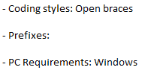

Main Loop

We have decided to use a multithreaded game loop for our main loop. With it we plan to have everything run simultaneous, so that includes AI, Animation, Sound, Player Input, World Simulation, Physics, and rendering the scenes for our game engine.